MOKO Graph

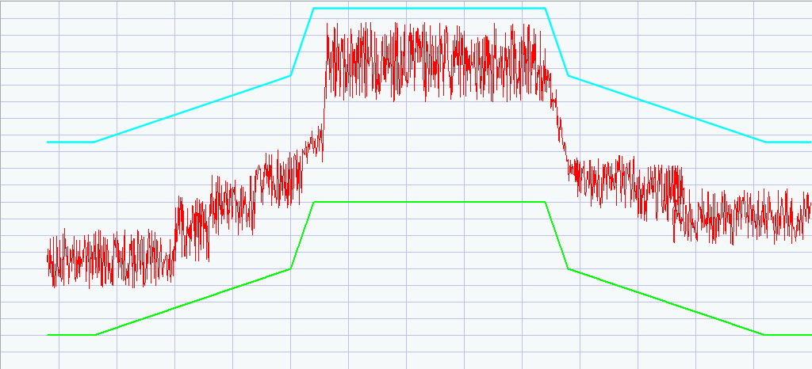
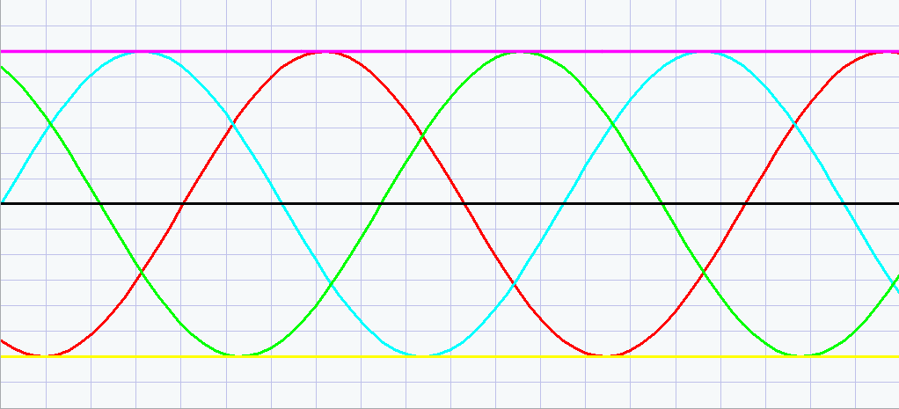

Iteration | x | y | Iteration | x | y | Iteration | x | y

Iteration | x | y | Iteration | x | y | Iteration | x | y

Screenshots:

Screenshot Graph

Screenshot Window
Iteration | x | y | Iteration | x | y | Iteration | x | y

Iteration | x | y | Iteration | x | y | Iteration | x | y

Screenshots:

Screenshot Graph

Screenshot Window
Iteration | x | y | Iteration | x | y

Iteration | x | y | Iteration | x | y

Screenshots:

screenshot graph

screenshot Window
Documentation
This section is dedicated to the functionality of the MGPH library and interact with it via the API.
MOKO Graph (MGPH) is designed to process numerical data and visualize the resulting data. The plugin has a main window and an auxiliary window with a minimalistic design that focuses the user's attention on the graphical representation of the data. At the bottom of the program there are buttons for using the main features of the program and indicating the status of the plugin.
The user has the ability to use commands, UI or the settings window to add coordinates for the chart, perform various operations on them, take screenshots.
API also allows you to receive certain information for further processing in a script or report. To use the API MOKO Graph uses the MGPH library.
– Adding a line:
MGPH.AddLine(name, *arroy, *arrox, linewidth, color, visible)
:param str name: Name lines
:param str arroy: Coordinates lines By axes ordinate
:param str arrox: The x-coordinate of the line
:param str linewidth: Thickness lines
:param str color: Color lines
:param str visible: Visibility lines
:return None
Example commands:
name = "Plot 1"
arrox = [0, 1, 2, 3, 4]
arroy = [0, 1, 2, 3, 4]
line width = 1
color="00FFFF"
visible = "Yes"
MGPH.AddLine(name, *arroy, *arrox, linewidth, color, visible)
After executing this command, the Plot 1 line appeared in the dropdown . In the Settings window, you can see the parameters of this line. However, the line does not appear on the chart.
– Displaying data on a graph:
MGPH.WriteGraph()
:return None
The result of executing this command is the appearance of the Plot 1 line on the chart.
– Changing the parameters of an already added line
MGPH.ChangeLine(numline, name, *arroy, *arrox, linewidth, color, visible)
:param int numline: Number lines
:param str name: Name lines
:param int * arroy: Y-axis coordinates of the line
:param int * arrox: The x-coordinate of the line
:param int linewidth: Thickness lines
:param str color: Color lines
:param str visible: Visibility lines
:return None
Example commands:
name = "Plot 1"
numline = 1
arrox = [0, 1, 2, 3, 4]
arroy = [6, 0, 1, 2, 3]
line width = 5
color="00FFFF"
visible = "Yes"
MGPH.ChangeLine(numline, name, *arroy, *arrox, linewidth, color, visible)
After executing this command, the parameters of the Plot 1 line will change.
– Remove lines:
MGPH.DeleteGraph(*numline)
:param int * numline : Line number or multiple line numbers
Numbers of several lines are transmitted as a list. Also, the function accepts a single string value “All”, which will cause all lines to be deleted.
Example commands:
numline = [0, 1, 2, 3]
MGPH.DeleteGraph(*numline)
MGPH.DeleteGraph(“All”)

